Lab 2

12. More Waves

Andrea Tuggle

05/02/2019

Physics II

Dr. Harrison

1. OBJECTIVE

The objective of this lab is to produce a transverse wave f(x,t) using springs and masses in Interactive Physics and Sage Math. We also will be using calculations to see the effects on velocity, amplitude and wavelength on waves.

1. DATA

The data used in this lab were multiple formulas and exponents:

- A= amplitude

- Vy= velocity in the y-direction

- 𝑃𝐸 = 1 /2 (𝑘)(∆𝑥^ 2 )

-𝐾𝐸 = 1 2 𝑚𝑣 ^2

-𝑓 = square root (𝑘 /𝑚)/ 2𝜋

Part 1:

Amplitude (A): 3 m

Wavelength (λ): 13 m

Mass of blocks: 10 kg

From the date above the frequency and period were able to be calculated.

Period= 1/Frequency= 3.62 sec

Frequency= 2.756

Part 2:

Using Sage Math, I created a standstill wave (which is shown in my results) using the wavelength equation provided on the Physics Interactive Lab.

1. CALCULATIONS

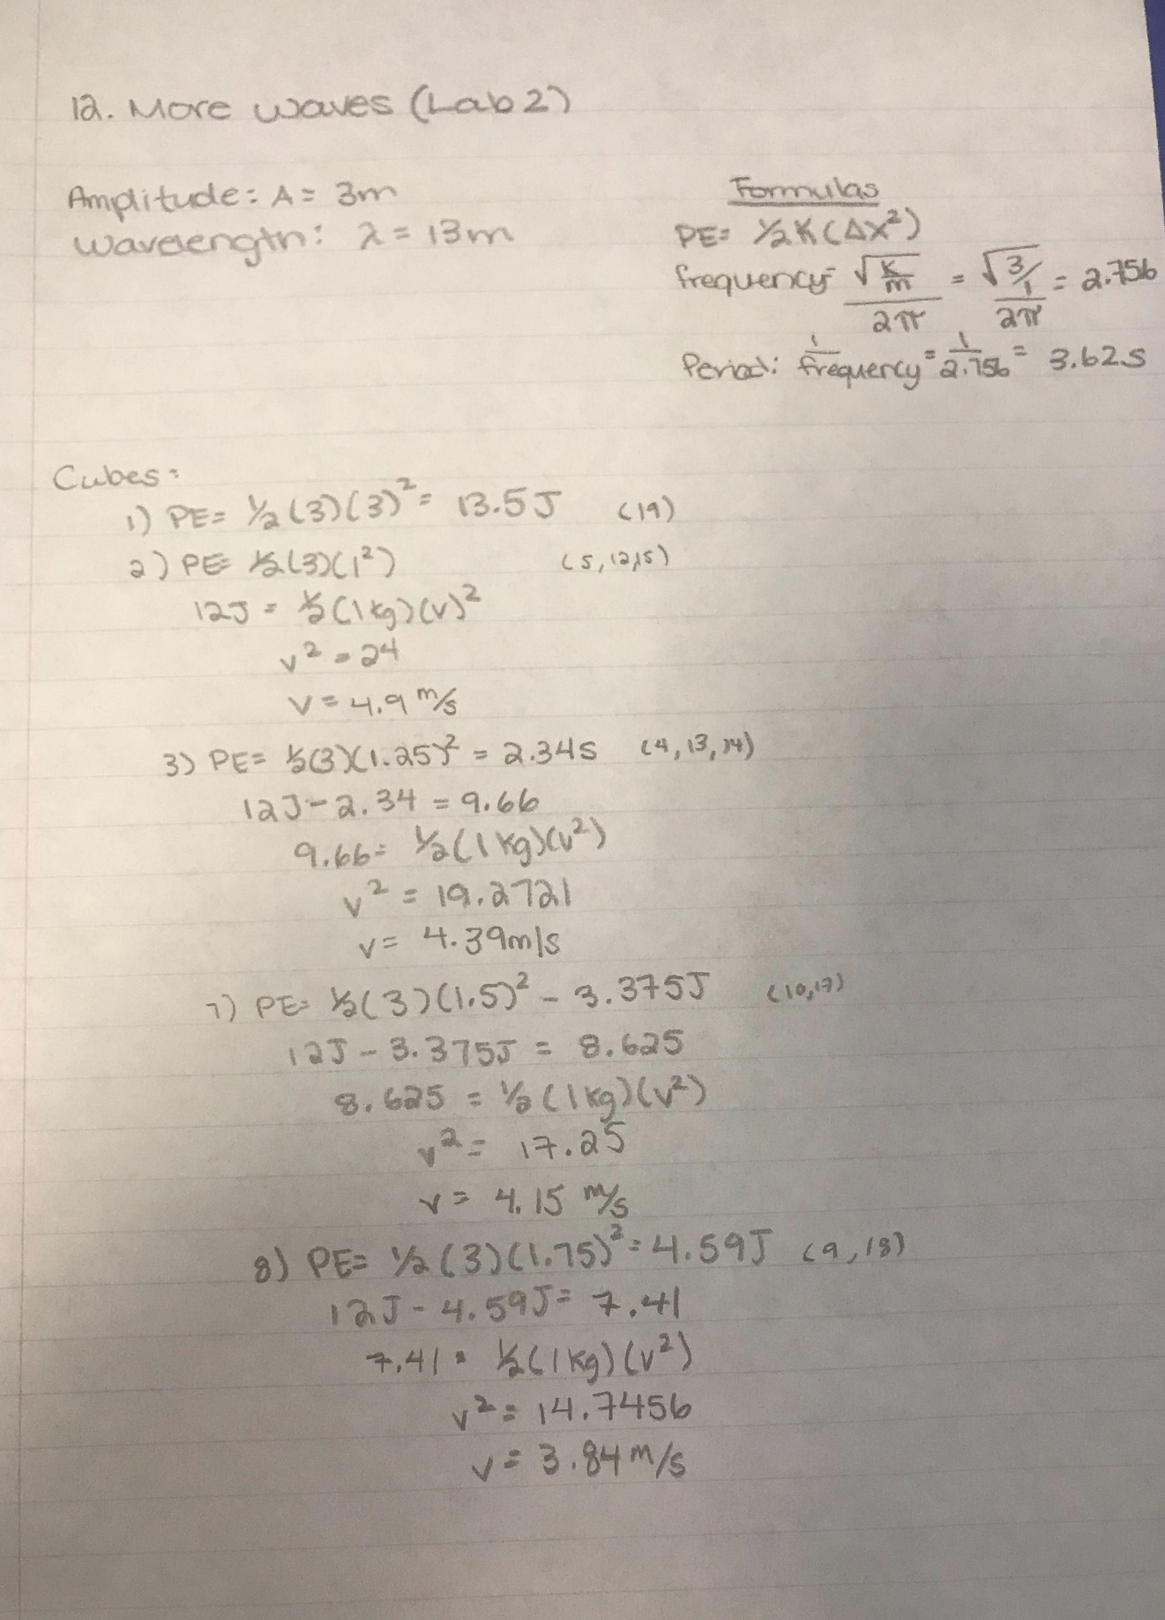

1. RESULTS

